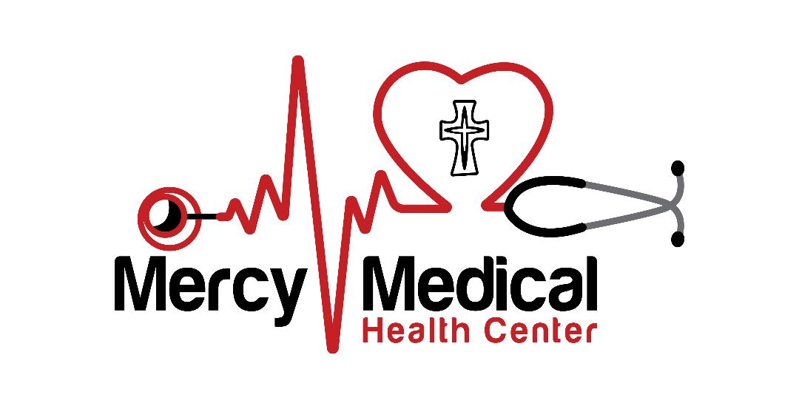
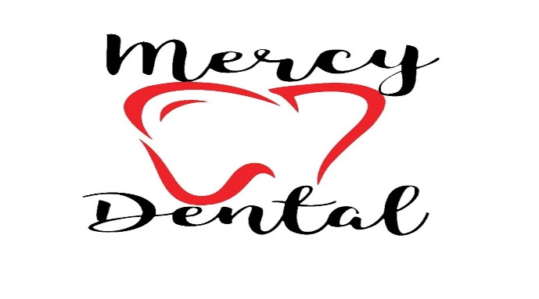
2022 Federal Poverty Guidelines 2022
Size of Household | 100% | 125% | 150% | 175% | 200% | >200%
1 | $13,590 | $16,988 | $20,385 | $23,783 | $27,180 | >$27,180
2 | $18,310 | $22,888 | $27,465 | $32,043 | $36,620 | >$36,620
3 | $23,030 | $28,788 | $34,545 | $40,303 | $46,060 | >$46,060
4 | $27,750 | $34,688 | $41,625 | $48,563 | $55,500 | >$55,500
5 | $32,470 | $40,588 | $48,705 | $56,823 | $64,940 | >$64,940
6 | $37,190 | $46,488 | $55,785 | $65,083 | $74,380 | >$74,380
7 | $41,910 | $52,388 | $62,865 | $73,343 | $83,820 | >$83,820
8 | $46,630 | $58,288 | $69,945 | $81,603 | $93,260 | >$93,260
*For households >8, add $4720 for each additional person
FPL% | up to 100% | up to 125% | up to 150% | up to 175% | up to 200% | >200%
Medical fee at time of visit | $10 | $22 | $34 | $46 | $58 | 100% of cost
Dental fee at time of visit | $60 | $70 | $80 | $90 | $100 | 100% of cost
Dental visit SFS | Patient pays 50 % for any carved out dental services (i.e. endo) | Patient pays 60 % for any carved out dental services (i.e. endo) | Patient pays 70 % for any carved out dental services (i.e. endo) | Patient pays 80 % for any carved out dental services (i.e. endo) | Patient pays 90 % for any carved out dental services (i.e. endo) | Patient pays 100% for any carved out dental services (i.e. endo)
*Over 200% FPG, patient pays full non-discounted price.

